STAT461 Project

Xiangyu Ren

11/23/2020

$$Y_{ijt}=μ+α_{i}+β_{ij}+ϵ_{ijt}, ϵ_{ijt}\overset{iid}{∼}N(0,σ^{2})$$

$$i=played,paused j=highResolution,lowResolution t=1,2,3,4,5$$

situ = c(rep("play", 10), rep("pause", 10))  
res = c(rep(c(rep("high-res", 5), rep("low-res", 5)), 2))  
time = c(156.27, 148.30, 163.58, 160.04, 152.93, 168.07, 170.32, 172.27, 163.49, 180.94, 190.87, 184.55, 183.73, 179.88, 191.01, 193.60, 190.56, 187.73, 184.35, 199.33)  
df = data.frame(situation = situ, resolution = res, time = time)  
model1 = aov(time ~ situation + resolution + situation:resolution, data = df)  
anova(model1)

## Analysis of Variance Table  
##   
## Response: time  
## Df Sum Sq Mean Sq F value Pr(>F)   
## situation 1 3110.02 3110.02 93.3770 4.415e-08 ***  
## resolution 1 495.01 495.01 14.8625 0.0014 **   
## situation:resolution 1 117.32 117.32 3.5225 0.0789 .   
## Residuals 16 532.90 33.31   
## ---  
## Signif. codes: 0 '***' 0.001 '**' 0.01 '*' 0.05 '.' 0.1 ' ' 1

plot(model1, which=c(1,2))

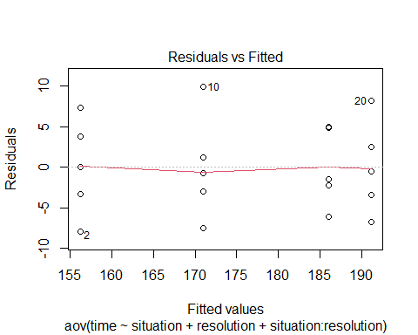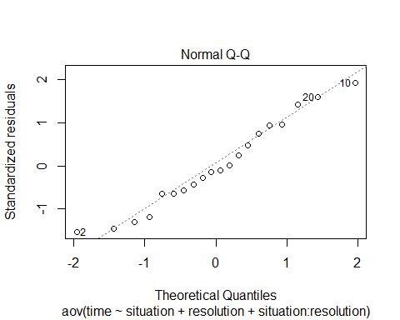

interaction.plot(x.factor = df$situation, trace.factor = df$resolution,response = df$time, type ="b",col =c("coral", "blue"),xlab ="Situation", ylab ="Mean", trace.label ="Resolution")  
  
library(emmeans)

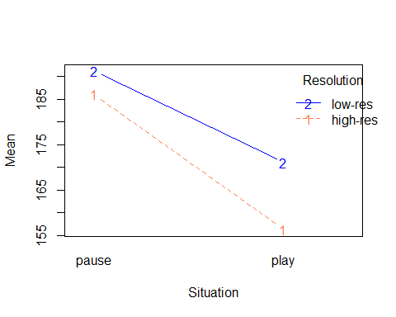

library(lsmeans)

## The 'lsmeans' package is now basically a front end for 'emmeans'.  
## Users are encouraged to switch the rest of the way.  
## See help('transition') for more information, including how to  
## convert old 'lsmeans' objects and scripts to work with 'emmeans'.

library(multcompView)

## Warning: package 'multcompView' was built under R version 4.0.3

library(multcomp)

## Warning: package 'multcomp' was built under R version 4.0.3

## Loading required package: mvtnorm

## Loading required package: survival

## Loading required package: TH.data

## Warning: package 'TH.data' was built under R version 4.0.3

## Loading required package: MASS

##   
## Attaching package: 'TH.data'

## The following object is masked from 'package:MASS':  
##   
## geyser

lsminter=lsmeans(model1,~situation:resolution)  
cld(lsminter, alpha=0.05)

## situation resolution lsmean SE df lower.CL upper.CL .group  
## play high-res 156 2.58 16 151 162 1   
## play low-res 171 2.58 16 166 176 2   
## pause high-res 186 2.58 16 181 191 3   
## pause low-res 191 2.58 16 186 197 3   
##   
## Confidence level used: 0.95   
## P value adjustment: tukey method for comparing a family of 4 estimates   
## significance level used: alpha = 0.05

$$H_{0}:(αβ)_{ij}=0\text{ for all }i,j vs. H_{a}:\text{at least one treatment is different}$$